|  |
| --- |
| **[ 2ceit604 User experience design]** |
|  |

Practical: 2

**AIM: Create Sketch of Login, Signup, Profile Information, Product List Page of Shopping Mobile App.(make one wireframe in figma or adobe)**



**Department of Computer Engineering/Information Technology**

1. **Login**

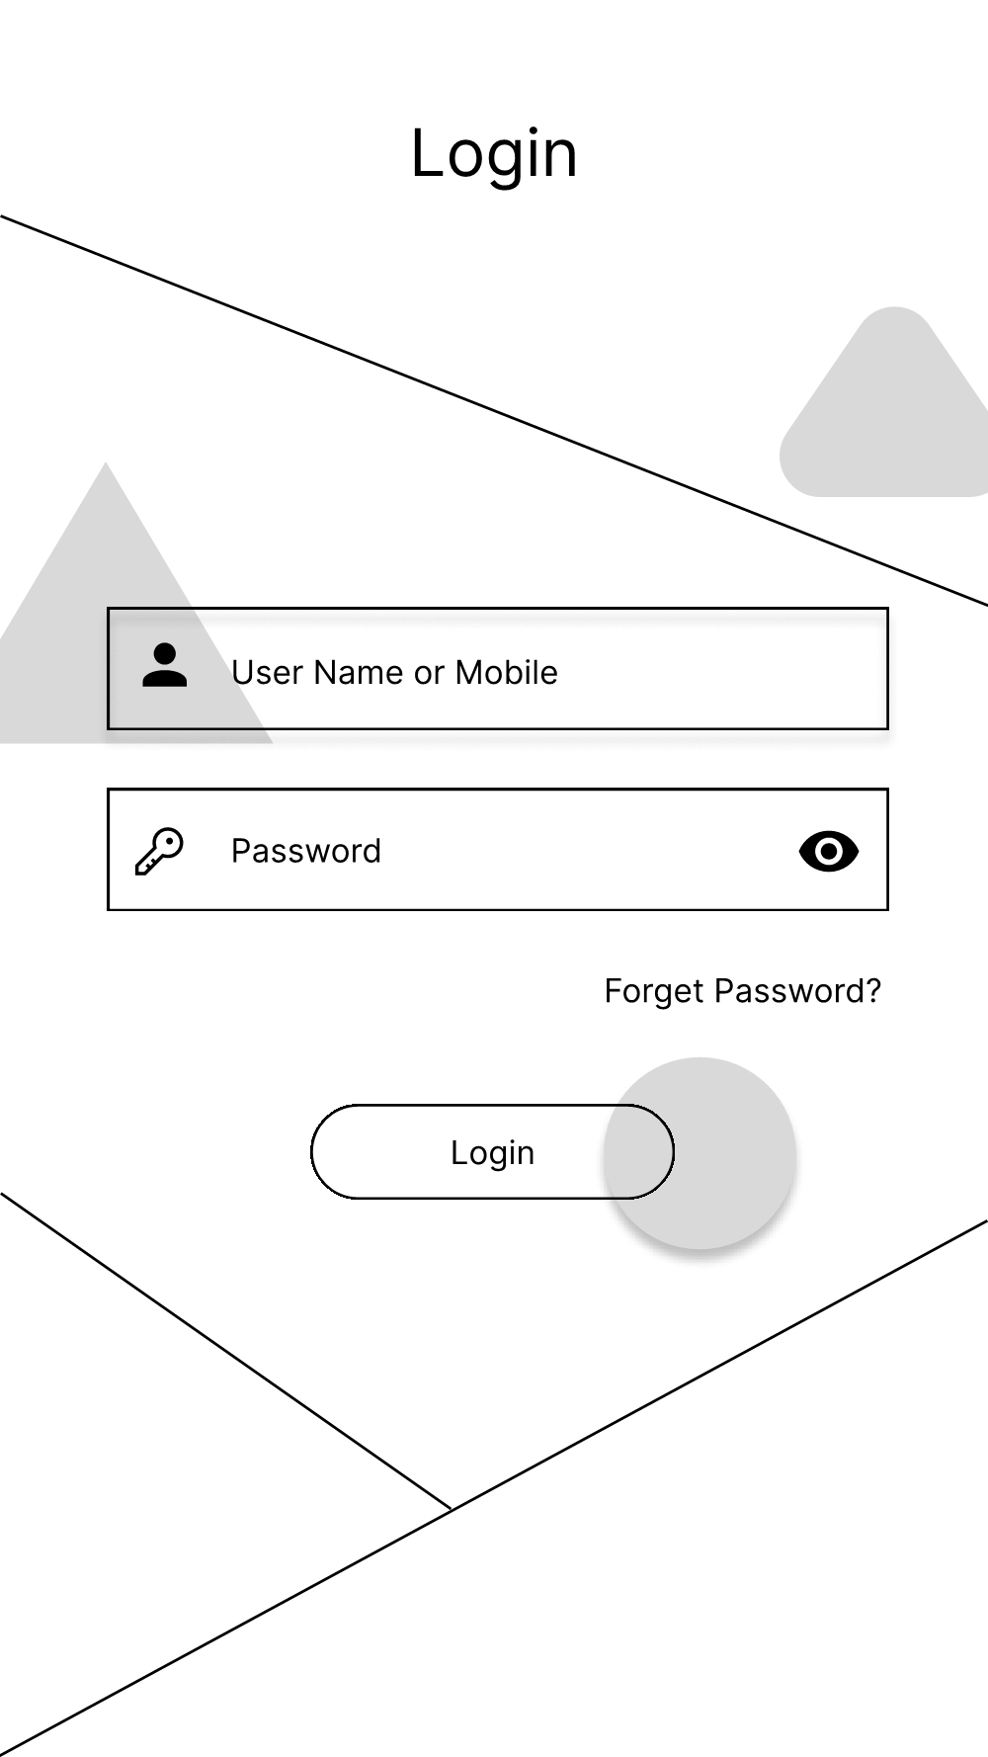

1. **Register**

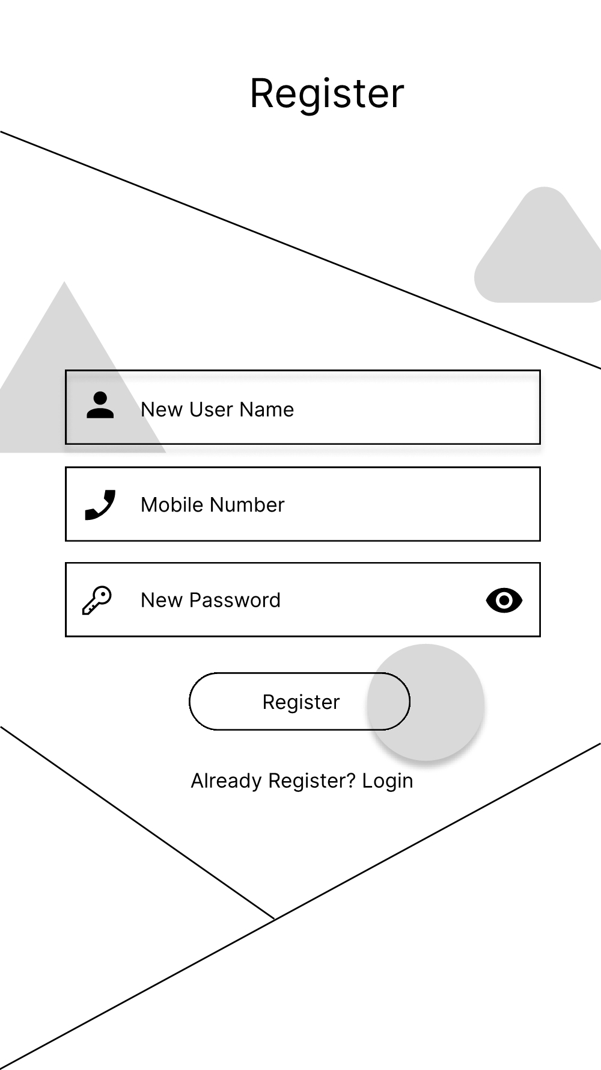

1. **Profile**

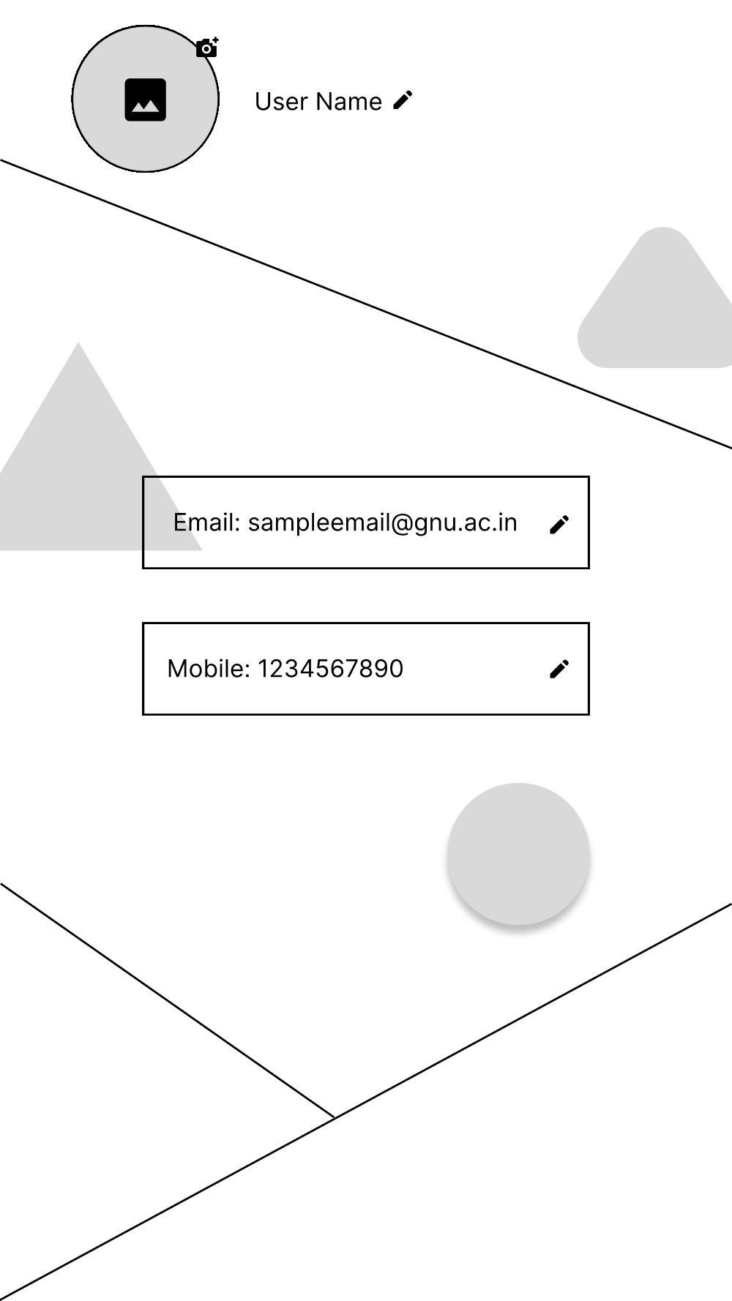

1. **Product List**

